

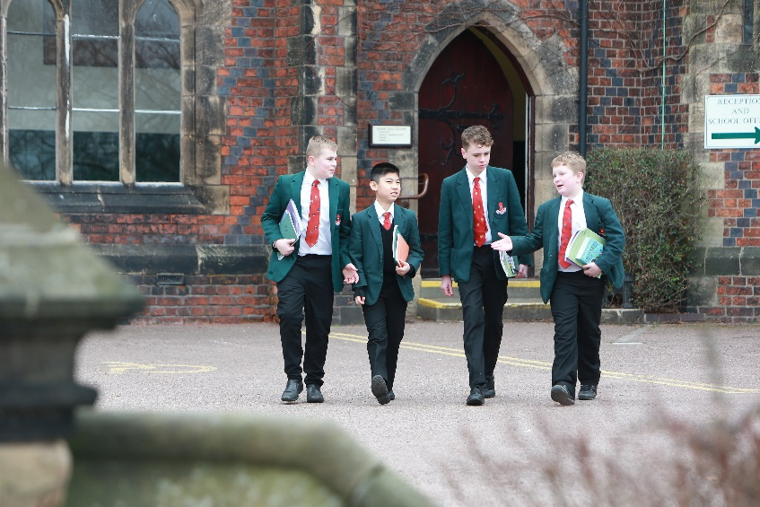

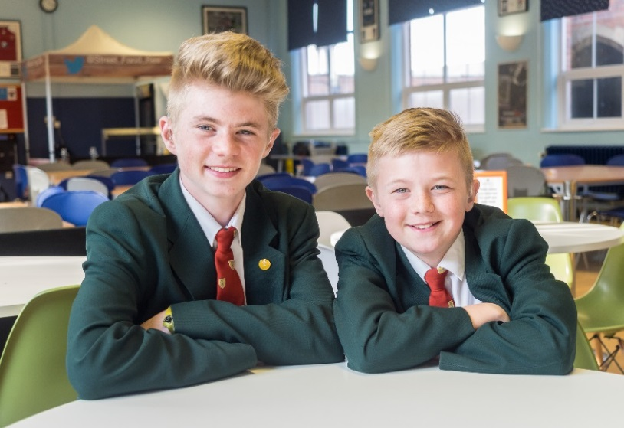

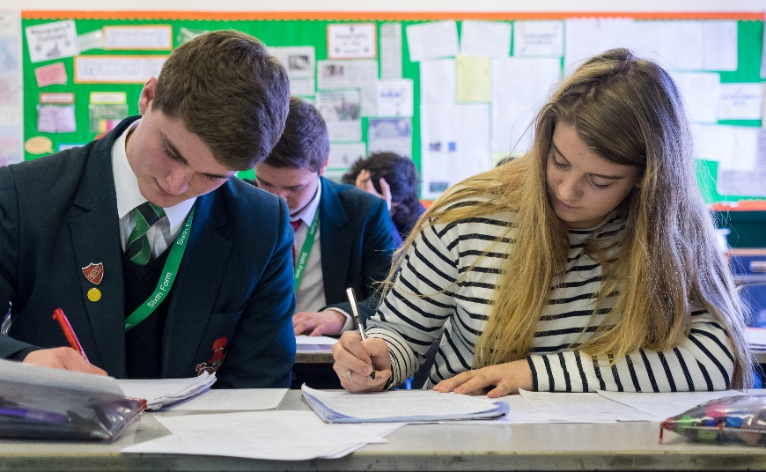

Application Pack for the post of
Temporary Learning Support Assistant - Grade 4
34 Hours per week – term time

Job Details – Learning Support Assistant

The School is looking to appoint a professional, enthusiastic, friendly and self-motivated team player to join our Learning Support team.

The successful applicant will work collaboratively with teaching staff, other support staff and external agencies to enhance the development and education of children in accordance with the aims and policies of the school. You will have the ability to display the skills required to motivate, inspire and challenge the pupils to succeed and have a natural ease with strangers and the ability to rapidly form relationships with empathy and maturity.

A more detailed job description and person specification is available below. If you feel you have the skills we are looking for we would encourage your application.

Sandbach School is committed to safeguarding and promoting the welfare of children and young people and expects all staff and volunteers to share this commitment. This post is subject to enhanced DBS disclosure and satisfactory references.

Job Description

Responsible to: Learning Support Manager
Hours: 34 hours, Term Time Only
Salary: £17,431 to £18,534 (£13,759 to £14,630 Annual Pro Rata)
Core purpose: To work collaboratively with teaching staff and work with other support staff to enhance
the development and education of children in accordance with the aims and policies of the school.

Job Description

- Provide one to one academic, social and emotional support to identified students.
- Be proactive in developing challenging and engaging learning activities in an inclusive environment.
- Provide support to meet the needs of individual students with specific medical conditions, including personal care.
- Plan and implement agreed learning activities for individual and groups of pupils, in collaboration with the teaching staff, to ensure that learning objectives and individual learning targets are achieved.
- Observe and monitor individual pupils to provide accurate assessments of progress and problem areas for the compilation of reports, and to provide appropriate feedback to pupils.
- Access and update the full range of pupil records to facilitate assessment of pupils’ progress, to include the use of Bromcom.
- Be responsible for devising and organising programmes of work within a specialist subject area.
- Supervise the activities of individual or groups of pupils, both in and out of the classroom (including educational visits), to ensure their safety and facilitate their physical and emotional development in accordance with the school’s managing behaviour strategies.
- Attend staff and other meetings and participate in staff training development work and staff reviews as required.

Other duties/Responsibilities

- As an employee of this organisation you may be asked to carry out duties at any of its establishments, at any time throughout the duration of your contract.
- You will also be required to carry out any other duties which may reasonably be required of you.

Notwithstanding the detail in this job description, in accordance with the School Policy the job holder will undertake such work as may be determined by the Headteacher/Governing Body from time to time, up to or at a level consistent with the Main Responsibilities of the job.

Person Specification

The successful candidate will support students with a range of learning needs but will predominantly be working with students with learning difficulties in a classroom environment. In addition, you will be expected to work as part of a team and support the Assistant SENCO to further develop the department.

Experience
Successful recent experience working with pupils/children of relevant age in a learning environment.

Qualifications/ Training
- Educated to A Level / NVQ level 3
- Have achieved a nationally recognised qualification at level 2 or above in English/ Literacy and Mathematics / Numeracy.
- Child Protection, Health & Safety and care legislation.

Knowledge and Skills
- Can use ICT effectively to support learning.
- Full working knowledge of relevant policies / codes of practice/legislation.
- Good working knowledge and experience of implementing relevant curricula and other relevant learning programmes.
- Good understanding of child development and learning processes.
- Good understanding of statutory frameworks relating to teaching.
- Constantly improve own practice / knowledge through self-evaluation and learning from others.
- Ability to relate well to children and adults.
- Understanding classroom roles and responsibilities and your own position within these.
- Ability to apply a range of behaviour management policies and strategies which contribute to a purposeful learning environment.
- Know how to contribute to effective personalised provision by taking practical account of diversity.
- Have sufficient understanding to support the development, learning and progress of children, young people and colleagues.
- Be able to interpret data to inform interventions.
- Know how to support learners in accessing the Curriculum in accordance with the SEN code of practice of disability legislation.
- Be able to demonstrate a specific SEN/D specialism pertaining to whole school need.
- Be able to demonstrate and have understanding of whole school accountability including parents, Line Manger, Headteacher and Governors.

Attributes
- Have high expectations of children and young people with a commitment to help them fulfil their potential.
- Establish fair, respectful, trusting, supportive and constructive relationships with children and young people.
- Demonstrate a commitment to collaborative and cooperative working with colleagues.
- Improve their own knowledge and practice including responding to advice and feedback.
- Work effectively as part of a team and contribute to group thinking, planning etc. with an ability to input strategically to the future development of the department.
- Effective time management.
- Build rapport with adults and children.
- To be flexible.
- Use own initiative and work independently.
- Excellent communication skills with adults and children, verbally and in writing.
- Motivate, inspire and have high expectations of pupils.
- Creative approach to problem solving.
- Ability to adapt quickly and effectively to changing circumstances/situations.
- Work calmly under pressure.
- Committed to personal and professional development.
- Ability to critically evaluate own performance.
- Ability to record and assess pupil progress/performance etc.
- Ability to lead & support other members of the LSD.

Application details overleaf

How to Apply

Please download and complete the application form from our website and e-mail your completed application to hcooper@sandbachschool.org. In order to promote fairness and consistency amongst applicants, only application forms fully completed will be accepted (please note that CVs will not be accepted).

Closing date for application is: Friday 11th December 2020

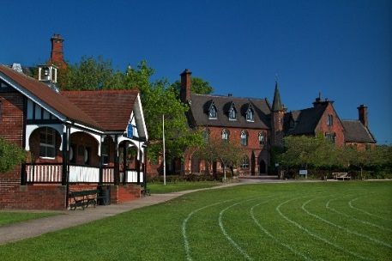
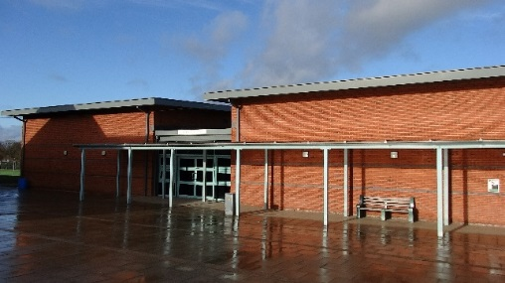


Sandbach School, Crewe Road, Sandbach, Cheshire, CW11 3NS, Tel: 01270 758870, E-mail: enquiries@sandbachschool.org

We aim to develop the compassion, aspiration and resilience of each student. When they leave us we want them to be at ease with themselves, to have a sense of self-worth, to have developed their talents and abilities and to be a valuable member of society.

