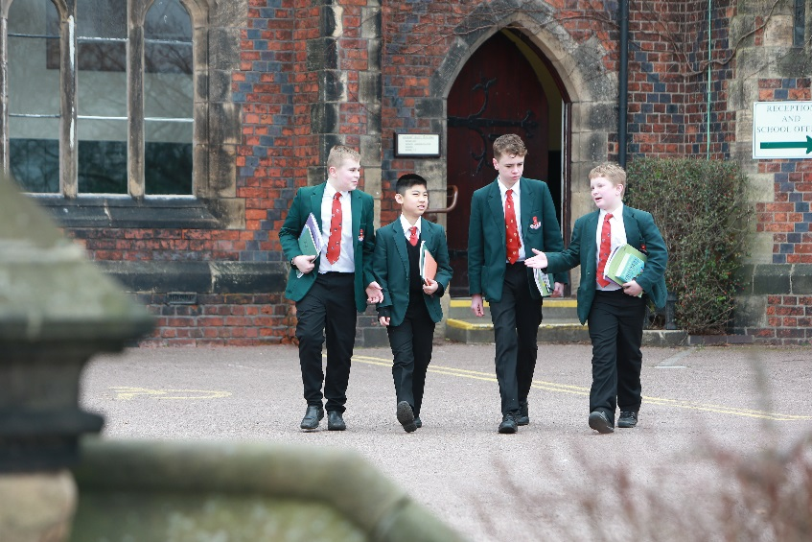

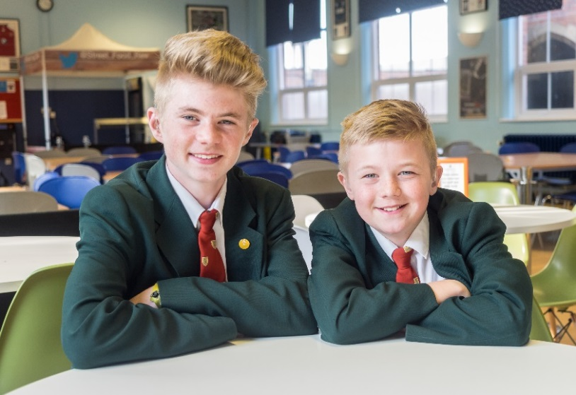

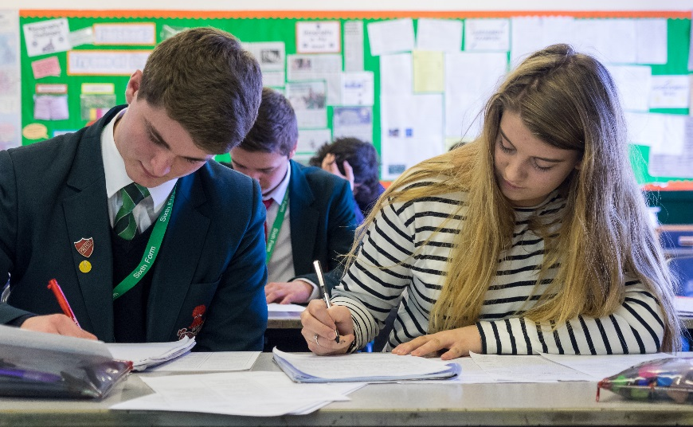

Application Pack for the post of
Teacher of Science
Permanent, Full-Time

Teacher of Science

Thank you for your interest in the above post. . . . .

Sandbach School is an 11-16 Comprehensive School for boys that has a co-educational Sixth Form. In September 2011 Sandbach School became one of the first 24 Free Schools, directly funded by the DfE and working autonomously from the Local Authority. It serves the communities of Sandbach, Haslington, Elworth and surrounding parishes in Cheshire East.

The school provides an inclusive education which goes well beyond curricular provision: blending traditions with innovation via both Year cohorts and a House system; prefects and a rigorous “colours” system; peer-mentoring and a strong pupil voice in an active School Council; Commemoration Day and Awards Ceremonies.

The range of extra-curricular provision is outstanding, encompassing sport, the Arts, Combined Cadet Force and myriad clubs and activities. Extra-curricular relations are used positively to enhance in-class dynamics.

We seek to recruit teaching staff with a philosophical commitment to outstanding comprehensive education both inside and outside the classroom. It is our belief that progress in all aspects of learning is affected by the quality of relationships forged within the school community, and that such relationships are unlikely to be maximised solely through the teaching situation. We recognise the entitlement of all pupils to a high quality and equality of experience, provision, care and support. To that end we endeavour to marry all that we see as best in education development with all that is desirable from the traditions of our past.

Our latest Ofsted report recognised the strength of our inclusive approach: “You have encouraged teachers and pupils to work together to deliver high quality leadership and education. Your staff feel valued, trusted and part of the school improvement process. Pupils are encouraged to engage with leadership in the school through the ‘Senate’. You encourage elected pupils that make up the ‘Senate’ to evaluate the effectiveness of the school’s work and contribute to further development of school policies.”

Thank you for your interest in a position at Sandbach School. I hope you will be enthused by what you read. If your experience and qualifications match our job specification, and if your philosophy of education stands comfortably with the expectations of the School, particularly in terms of providing added value outside the classroom, then I warmly invite your application.

Sarah Burns
Headteacher

Sandbach School and the Community

There are currently 1500 students on roll at Sandbach School (inc. 250 in Sixth Form)

The School is one of two single sex High Schools serving the educational needs of Sandbach and its surrounding area.

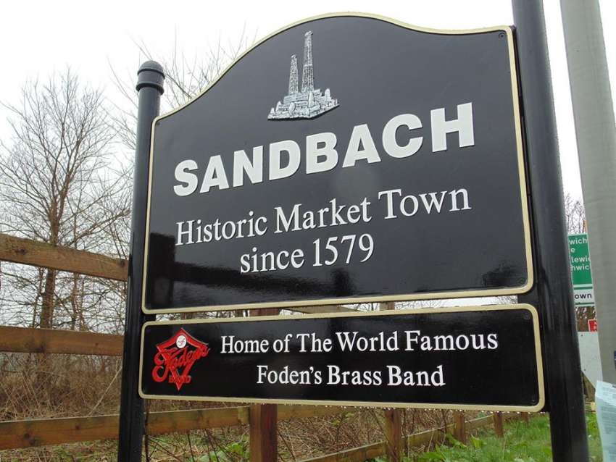
Sandbach is a pleasant, thriving and expanding market town of around 18,000 inhabitants situated within minutes of the M6. Its traditional employment base was engineering (Fodens and ERF Trucks, with movement towards British Rail and Rolls Royce/Bentley in Crewe). In recent years those industries have declined and numerous service industries have prospered and the geographical situation of the town has attracted a growing commuter population. Stoke on Trent can be reached within 20 minutes, Manchester City Centre within 40 minutes.

The town enjoys a strong community identity and within this Sandbach School is well supported; many families have current or historic links with the School. The local Rugby Club – Sandbach RFC – was formerly the Old Sandbachians, while past and present pupils provide much of the support for the local hockey, soccer and cricket clubs. The Old Sandbachians Association enjoys considerable community standing and meets regularly both locally and in London. Community expectations of the school are high.

Applicants from outside the South Cheshire area will discover a range of housing of all types available, with opportunities to live in the larger local towns (Congleton, Nantwich, Alsager, Holmes Chapel, Crewe and Newcastle), in small villages, or in rural isolation. South Cheshire and the neighbouring areas of North Staffordshire and Shropshire offer an enviable quality of life with a richness of social, cultural and recreational provision.

School History

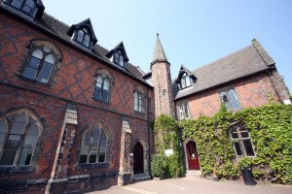
Although Sandbach School was founded in 1677 as a Parish Charity, its present site near to the centre of town was not occupied until 1849, when George Gilbert Scott designed the impressive buildings which form the façade of the present and much extended School.

Building has continued at regular intervals, most recently in 2021 with the opening of the Dunning Arts Centre.

In 2011, we became a Free School and to date we operate as a stand-alone academy.
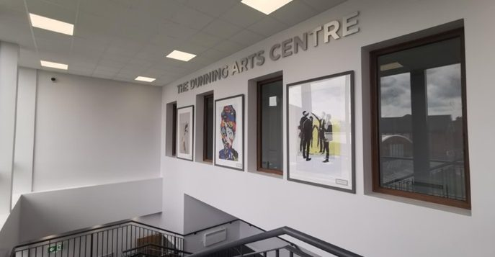
However, Sandbach School is fully committed to working in partnership with schools and community groups. Local partnerships include being an integral part of the Chimney House Alliance (a formal collaboration of 14 secondary schools in East Cheshire), as well as the Sandbach & Haslington Education Improvement Partnership across the two Sandbach Secondary Schools and their feeder primaries.

Sixth Form

Sandbach School Sixth Form is a dynamic and vibrant place where students are given the freedom and opportunities to develop as individuals as they make important steps towards Higher Education or employment.

Our Sixth Form has a tradition of balancing academic excellence with the best extra-curricular and leadership opportunities thus helping students to make the most of their time here. They are supported and guided along the way by dedicated and experienced staff who are there to provide them with the best possible experience.

Sixth Form Facilities

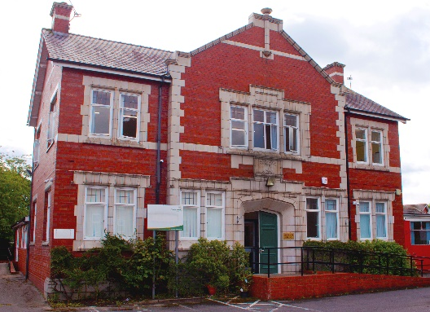
In 2019, the school purchased Sandbach House, which is a hub for our Sixth form. Situated across the road from the main site, the historic town-building houses social science and creative media classrooms, a large study space, a kitchen as well as sixth form offices.

Sandbach House allows our students to enjoy their own dedicated facility whilst still being a thriving part of the school environment.

Mission and Values
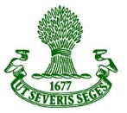
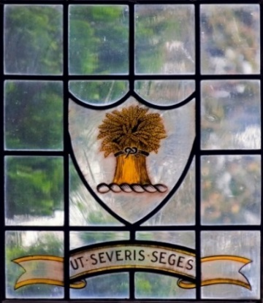
The core values of Sandbach School are those embodied in the School’s motto and crest displayed on all uniform badges and school documentation. Such values are known, understood and should be practised by all members of the Sandbach School Community.

The Latin motto “Ut Severis Seges” broadly translates as “As you sow, so shall you reap” or the more you put into school life, the more you will get out of it. The crest of the Cheshire wheatsheaf suggests that care, nurturing and commitment are needed to achieve a harvest of quality. Applying both concepts to an all-boys comprehensive school, the values which the motto and crest encapsulate are:

- Commitment to excellence in all aspects of school life – “working hard and playing hard”.
- Respect for self and others, combined with a responsibility and caring for all members of the school and its wider community.
- Integrity, honesty and open-ness in how every member of the school community operates.
- Encouragement of all to be creative, innovative and able to take initiative in order to develop every individual beyond their perceived potential.

Such values are regularly communicated, reinforced and celebrated in assemblies, performances, fixtures, formal documentation and the School’s website.

Extra Curricular

The school runs an extensive programme of extra-curricular activities. Many activities change each term and information is regularly updated on our website.

At our most recent inspection Ofsted commented:

“The school’s record of sporting prowess and pupils’ strong cultural development has been sustained through a rich variety of extra-curricular activities. Those pupils that do not enjoy sports as much can access a wide range of clubs that take place regularly. These include drama club, band practice and the science, technology, engineering and mathematics (STEM) club.” Ofsted

Please take a look at our website for a further insight into Sandbach School www.sandbachschool.org
We aim to develop the compassion, aspiration and resilience of each student. When they leave us we want them to be at ease with themselves, to have a sense of self-worth, to have developed their talents and abilities and to be a valuable member of society.

The Science Department

The Science Department at present consists of 11 full time specialist Science teachers who form a friendly, supportive and forward-looking team. They are ably supported by 3 technicians.
Pupils are taught in mixed ability groups in years 7 & 8. Students are set by ability in Year 9. At Key Stage 3 (Year 7 and 8) there is a strong and increasing emphasis on Working Scientifically strategies. The Department has its own bespoke and engaging KS3 curriculum, accessible to all, providing secure feedback on student progress and respecting the recent changes to the National Curriculum.
At KS4, the department delivers the AQA Combined Trilogy specification and Single Science GCSEs.
At KS5, we offer the AQA A level courses in all 3 sciences. The Science A-Levels are a popular choice and we often have two classes for each of the Sciences in Year 12 and 13.
The Department aspires to have high academic standards and is fully committed to supporting the needs of all pupils irrespective of ability. In 2022, 82% of students achieved a grade 4 in at least one Science GCSE. 72% of all students achieved 2 or more GCSE grade 4’s in Science subjects. Recent triple Award figures were also extremely good, outperforming national averages with Grade 7+ percentages for Biology, Chemistry and Physics being 46%, 36.2% and 53.4% respectively.
The Science Department is keen to enthuse students in science. To support this, we run a weekly science club for Y7 & 8 students, IRIS project club for KS4 students and run regular trips for various groups including; a trip to CERN for A-Level Physics students, a trip to the Big Bang event for KS3/KS4 students, a Biology residential field trip for A-Level Biologists. We are looking to expand this offering to further encourage students to get involved with science and the ability to offer additional science extra-curricular activities would be an advantage.
At present, the department consists of 9 science laboratories and two preparation rooms. All laboratories have a computer & large TV screen for presentations. The department also has exclusive use of a set of laptop computers with wireless access, visualisers and10 full sets of Data Harvest logging equipment.

Job Details –Teacher of Science

The school is now keen to further strengthen the department through the appointment of a dynamic, creative Teacher of Science.

The successful candidate will be someone who is:
- an able scientific practitioner, capable of teaching across the full age and ability range
- have an enthusiastic approach, aiming for high standards in teaching and learning
- a team player who will contribute towards the continued development within the department
- set the highest standards for yourself and those you teach.
- continue to drive forward the school’s culture of Learning and Teaching innovation.
- share good practice and resources with other members of the school.

The Department and the School are fully committed to providing high quality professional development.

The person appointed will be line managed by the Curriculum Leader of Science.

Job Description for Teacher of Science

Responsible to: Curriculum Leader

Core purpose: To facilitate inspirational learning

Main Responsibilities:
- To implement and deliver relevant and differentiated learning for students and to support a designated curriculum area as appropriate.
- To monitor and support the overall progress and development of students as a teacher/Form Tutor.
- To contribute to raising the standards of student attainment.
- To share and support the school’s responsibility to provide and monitor opportunities for personal and academic growth.

Key Tasks:

- To assist in the development of appropriate syllabuses, resources, schemes of work, marking policies and teaching strategies in the curriculum area and the department.
- To contribute to the curriculum area and department’s development plan and its implementation.
- To plan and prepare courses and lessons.
- To contribute to the whole school’s planning activities.
- To take part in the school’s staff development programme by participating in arrangements for further training and professional development.
- To continue personal development in the relevant areas including subject knowledge and teaching methods.
- To engage actively in the Performance Management Review process.
- To ensure the effective/efficient deployment of classroom support.
- To work as a member of a designated team and to contribute positively to effective working relations within the school.
- To maintain appropriate records and to provide relevant, accurate and up-to-date information for SIMS, registers etc.
- To complete the relevant documentation to assist in the tracking of students.
- To track student progress and use information to inform teaching and learning.
- To communicate effectively with the parents of students and external agencies, as appropriate.
- To take part in marketing and liaison events with partner schools.
- To assist the Curriculum Leader to identify resource needs and to contribute to the efficient/effective use of physical resources.
- To be a Form Tutor to an assigned group of students.
- To promote the general progress and well-being of individual students and of the Form Tutor Group as a whole.
- To liaise with a pastoral leader to ensure the implementation of the school’s Pastoral System.
- To register students, accompany them to assemblies, encourage their full attendance at all lessons and their participation in other aspects of school life.
- Involvement in Extra-curricular and House activities.

Person Specification

Criteria | Requirements
Qualifications | - Good degree in Science  - QTS  - Excellent subject knowledge to challenge and inspire all students  - Ability to teach A level is essential
Experience | - Proven record within a department for facilitating outstanding learning and progress in Science or NQT with the potential to be outstanding.
Skills and Aptitudes | - A passion for teaching  - Ability to engage and motivate students of all abilities across all key stages  - Excellent ICT skills including use of new technology to enhance teaching and learning.  - Excellent classroom management skills  - Ability to work collaboratively and creatively to develop the Science Curriculum.  - Willingness and initiative to try new approaches and ideas  - A positive attitude towards professional development and self-learning  - Excellent time management
Other requirements | - Willingness to lead and contribute to extra-curricular activities  - Excellent punctuality and attendance record  - Commitment to further developing own professional knowledge, skills and experience

How to Apply

Please download and complete our application form from our website and e-mail your completed application to mhayes@sandbachschool.org together with a supporting letter of no more than 2 sides of A4 detailing how you fulfil the requirements of the post. In order to promote fairness and consistency amongst applicants, only application forms fully completed will be accepted (please note that CVs will not be accepted).

Closing date for application is: Monday 2nd October 2023
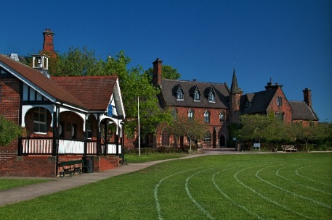
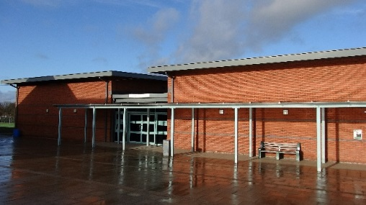
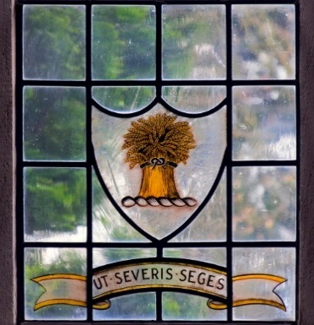

Sandbach School, Crewe Road, Sandbach, Cheshire, CW11 3NS, Tel: 01270 758870, E-mail: enquiries@sandbachschool.org

